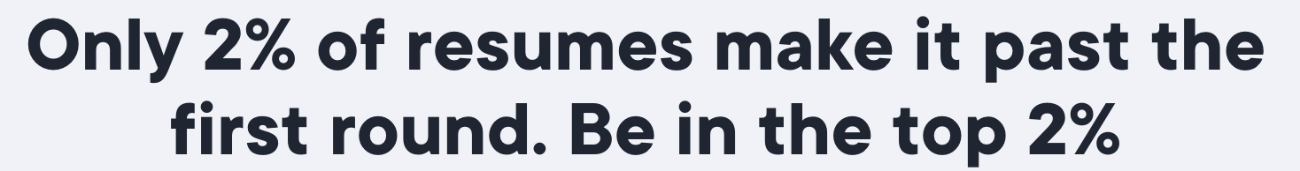

**Art and Science of ATS-Friendly Resumes**

✅ [**Austin Belcak’s** Analysis of 125,484 Resumes](https://cultivatedculture.com/resume-statistics/)

✅[5 Mistakes Highlighted by Hiring Managers](https://cultivatedculture.com/write-a-resume/)

✅[Write a Perfect RESUME.](https://www.toptechnewsletter.com/p/write-a-perfect-resume-5-science)

# 3 Most Important Parameters:

1. Format
2. Keywords
3. Impact
4. **Formatting Tips for ATS Algorithim’s Compatibility**:

* Use standard fonts like Arial, Times New Roman, or Calibri.
* Avoid using tables, graphics, images, and logos as ATS might not read them correctly.
* Stick to clear and conventional headings like “Work Experience,” “Education,” and “Certifications.”
* Use bullet points, bold, and italics for emphasis, but avoid text boxes or columns that can confuse ATS.

**Most Important Remember:**

* **Tailor your resume for each job you apply for.**
* Focus on including relevant keywords and achievements. (From Specific JD)

1. **Keywords:**
2. Full Job description <copy and paste in cloud word generator>Tagcrowd.com
3. Sprinkle those keywords all over your resume. Use **ChatGpt Prompt**: *Can you suggest some additional relevant keywords from the job description above and integrate them into the following resume content below?*

**3) Impact**

1. **Quantify your Projects and Work Exp.**  
   **Use Chatgpt Prompt**:*I am preparing my resume to apply for [Job Title/Position] and need to quantify my project work to highlight my skills and achievements effectively. Despite not having prior professional experience, I have worked on several projects that are relevant to this role. Can you help me quantify my accomplishments in these projects to make my resume more impactful?"*

**Follow this Order of Information**.

1. **Contact Information**
2. **Professional Summary**
3. **Work Experience**
4. **Skills(Technical and Softskills)**
5. **Certifications**
6. **Education**
7. **Additional Sections (if applicable)**:

Here is a brief description of what to include under each title:

1. **Contact Information**: Full name, phone number, email address, LinkedIn profile, and location.
2. **Professional Summary or Profile**: A brief 2-3 sentence overview of your experience and key skills.

*Prompt: Draft a concise summary for an IT engineer’s resume that highlights key achievements and skills according to the job description below to pass ATS checks. Focus on quantifiable results and specific expertise related to the role, in 2-3 lines. Avoid clichés and buzzwords.*

1. **Work Experience**: Listed in reverse chronological order. Include job title, company name, location, and dates of employment. Highlight key achievements and responsibilities using bullet points

*Prompt: For each previous job role, write detailed bullet points that reflect your responsibilities and achievements. Use the job description to sprinkle in relevant keywords. Include 5-6 points for the latest job and 3-4 points for previous roles, with quantifiable metrics.*

1. **Skills**: A list of relevant skills **tailored** to the job you are applying for. Use bullet points for clarity and include both hard and soft skills.

*Prompt:Create a skills section that lists both technical and soft skills relevant to the job description avoid generic terms and cliches. Only give headings without any Description*

1. **Education**: Degrees, institutions, and graduation dates listed in reverse chronological order.
2. **Certifications and Training**: Relevant certifications with issuing organizations and dates.

Note: Write trained if you do NOT have any certificates but do mention it. Example: Azure Administrator trained.

1. **Additional Sections (if applicable)**:
   1. These can include volunteer work, Awards, Recognition (Optional), publications, projects, **Hobbies, Strengths,** or any other relevant information,

**Final Step: Grammar and Spelling Check:**

1. Copy and paste your Newly created Resume below this prompt.

**Use ChatGpt Prompt:** "*Could you please correct any spelling or grammar mistakes in my resume? Additionally, could you provide me with a comparison table showing what you have corrected versus my original text, highlighting only the corrections and not the entire content?"*

1. Remove all Buzz words and Cliches from your Resume.



Other FAQs:

1. Should I add my photo on the Resume?

* Short answer No

1. Is a Cover letter compulsory for every role?

* Not Compulsory, if asked you must attach.